Prueba saber 11

**Parte 4**

WOLF COFFEE

110. A. saying 16. A. every

111. B. his 17. C. a

112. C. these 18. B. whit

113. B. larges 19. C. at

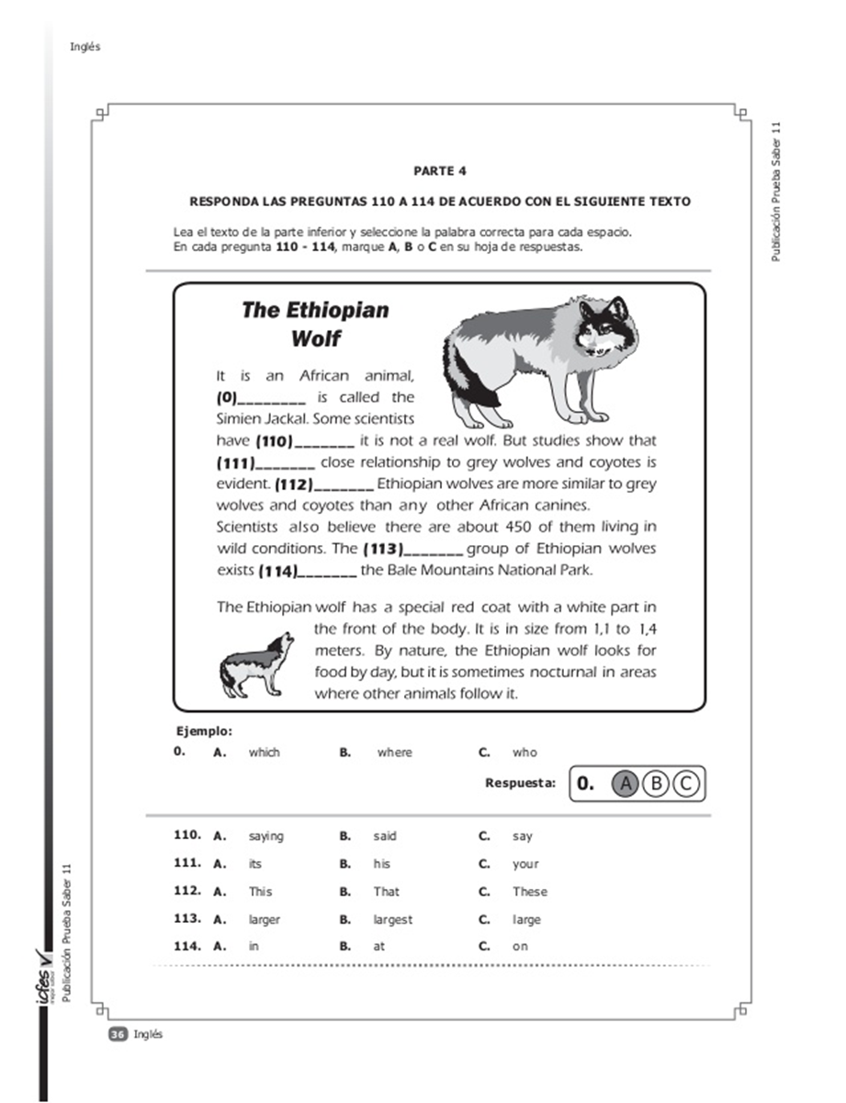114. A. in 20. B. opened

21. A. these

22. C. because

23. B. cheap

